A Review of State Data Centers Indicators, Tools, and Methods
Technical Report

Treena Goswami, https://orcid.org/0009-0004-6289-836X
Jianing Cai,
Marijke van der Geer,
Vicki Lancaster, https://orcid.org/0000-0002-1517-3807
Neil Kattampalil, https://orcid.org/0000-0002-4092-1897
Stephanie Shipp, https://orcid.org/0000-0002-2142-2136
Emily Molfino, US Census Bureau, https://orcid.org/0000-0002-6575-030X

Social and Decision Analytics Division
Biocomplexity Institute
University of Virginia

January 4, 2024 – DRAFT


Funding: This research was sponsored by the U.S. Census Bureau Agreement No. 01-21-MOU-06
Acknowledgments: We thank Joseph Salvo, the University of Virginia’s Biocomplexity, the Federal-State Cooperative for Population Estimates, and other report reviewers (to be filled in).
Citation: Goswami T, Cai J, van der Geer M. Lancaster V, Shipp S. A Review of State Data Centers Indicators, Tools, and Methods Technical Report, 2024 Proceedings of the Biocomplexity Institute, Technical Report. TR# 2024-XXX. University of Virginia. DOI

Abstract

This project focused on the evaluation of state constitutions and amendments, State Data Centers (SDCs), and Federal-State Cooperative for Population Estimates (FSCPE) representatives to better understand how state governments utilize data and to identify the federal, state, and private data sources they use. This report highlights the results of our data discovery process. In addition, we surveyed FSCPE directors, asking them about the top six data sources they use. The report looks at the six categories on which the SDCs commonly provide data: demographic, economic, housing, health, education, and diversity. We describe the information SDCs provide on their websites, their data dissemination methods, and the levels of geographies used. We define and select four early adopters' states as exemplars for the Census Bureau to study.

This project was ambitious in undertaking multiple approaches to understand the state and local data needs and how SDCs meet those needs. We provide a list of near-term recommendations that the Census Bureau could implement to supplement and enhance the SDCs. One of our primary recommendations is that the Census Bureau conduct a deeper dive into fewer states, starting with our list of early adopters (Colorado, New Mexico, Kansas, and New York) and proactive data developers (Utah and North Carolina). A deeper dive could include a more detailed review of the website, interviews, focus groups with the SDC and Coordinating Agency employees and data users, and other methods to provide a richer overview of SDCs.

Rerun Table of Contents after making changes.

Table of Contents
Abstract 2
Table of Contents 3
1. Introduction 4
2.0 Findings 5
2.1 State Constitutions and Amendments and State Data Center Mission Statements 5
2.2 State Data Centers 5
2.2.1 SDC Mission Statements 6
2.2.2 SDC Data Dissemination Websites 8
2.2.3 SDC Data Sources and Level of Geographies 9
2.2.4 SDC Early Adopters 11
2.3 Survey of the Federal-State Cooperative for Population Estimates (FSCPE) Contacts 11
2.4 Exploration of a Search Platform, Databases, and Nonprofit and Commercial Websites 14
2.4.1 Search Platforms 14
3.0 Methods 15
3.1 Text Analysis of State Constitutions and Amendments 15
3.2 Web Scrape of SDC Internet Sites 16
3.3 Manual Audit of State Data Center Websites 17
3.4 Survey of the Federal-State Cooperative for Population Estimates Contacts 17
3.5 Exploration of Search Platforms, Databases, and Websites 17
4. Conclusions 19
5. Recommendations 20
References 21
Appendix 22

A Review of State Data Centers Indicators, Tools, and Methods
Technical Report
Treena Goswami,¹ Jianing Cai,¹ Marijke van der Geer², Vicki Lancaster,¹ Stephanie Shipp,¹
Emily Molfino³

¹ University of Virginia, Biocomplexity Institute, Social and Decision Analytics Division
² San Diego State University
³ US Census Bureau

1. Introduction

The objective of this project is to support the U.S. Census Bureau in the establishment of the 21st Census Century Curated Data Enterprise (Keller et al. 2022) by reviewing what and how data sources are used by State Data Centers (SDC) and their affiliates. This includes identifying the data sources and tools they use, the statistical products they produce, and standard practices among the SDC network. The Census Bureau would like to accelerate how they address state, regional, and local government and analysts' data needs by creating tools and data products that facilitate data access by users at all levels of data acumen (Keller & Shipp 2021).

State Data Center (SDC) plays a role in providing accessible, accurate, and timely information to data users through a mutually beneficial partnership with the U.S. Census Bureau. Acting as an intermediary, the SDC network facilitates connections between local groups, individuals, and the Census Bureau’s statistical products. Each state designates one lead SDC agency, often affiliated with diverse organizations such as universities, libraries, and research centers. Additionally, states may have multiple coordinating agencies contributing to the collaborative effort. This report examines SDCs in the 50 states, the District of Columbia, Guam and Puerto Rico territories.

This report begins with a discussion of our findings in Section 2. This is followed by a discussion of the approach and methods used in Section 3, including the following topics:

1. Text analysis of state constitutions and amendments;
2. Text analysis of SDC mission statements;
3. Web scraping SDC internet sites;
4. Manual audit of the SDC websites;
5. Survey of the Federal-State Cooperative for Population Estimates (FSCPE) contacts;
6. Exploration of search platforms and databases.

We also include a discussion of data sources and the level of geographies used, how the data were disseminated, and early SDC adopters. We end with conclusions and recommendations in Sections 4 and 5.
In addition to this report, we have developed a publicly accessible dashboard (https://treenagoswami.shinyapps.io/project_website/) that includes a visual analysis of different geographic levels of information provided across selected states and territories, the age of the data used, historical data availability, and results from text analyses of all SDC’s mission statements, except for the 15 states and territories that did not have mission statements.

2.0 Findings

2.1 State Constitutions and Amendments and State Data Center Mission Statements

Having manually searched and employed topic modeling on various state constitutions, we concluded that these documents predominantly encompass broad topics. While these topics and words are interesting to explore, they do not tell us what data a state requires, uses, or needs. Consequently, we turned our attention to State Data Centers’ websites. For details on the text analysis methods used, see Section 3.

2.2 State Data Centers

The State Data Center (SDC) Program is a cooperative program between the states and the Census Bureau that was created in 1978 to make data available locally to the public through a network of state agencies, universities, libraries, and regional and local governments.

SDCs provide data users with data and information. The SDC network is a key intermediary for the Census Bureau to help groups and individuals at the local level connect with Census statistical products.

Each state has one lead SDC agency and one or more coordinating agencies. These agencies are from numerous types of organizations: Libraries, State Agencies, Universities, and Others. Below is a visualization of the type of lead agency for each state. See Exhibit 1.

31 State Agency-led SDCs, e.g., Virginia’s SDC is led by the Virginia Economic Commission; New Hampshire Office of Planning and Development

4 Library-led SDCs, e.g., Nevada State Library and Archives; Missouri State Library

14 University-led SDCs, University of Vermont’s Center for Rural Studies; University of Mississippi’s Center for Population Studies

2 Other type SDCs, Arizona Commerce Authority (ACA) is an economic development organization; Connecticut’s CT Data Collaborative is a nonprofit organization

Exhibit 1: Type of SDC Lead by State, 2023
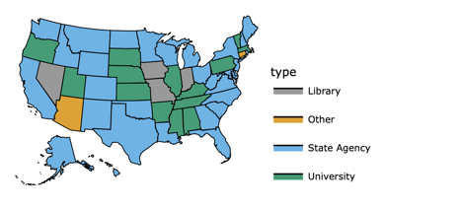
Note: An Interactive version of this map is in the dashboard. See https://treenagoswami.shinyapps.io/project_website/

Many states have coordinating agencies that provide data support to users, supplementing the SDCs. The number of coordinating agencies ranges from 0 in 10 states to 7 in 1 state, Missouri. See Exhibit 2.

Exhibit 2: Number of Coordinating Agencies by State, 2023
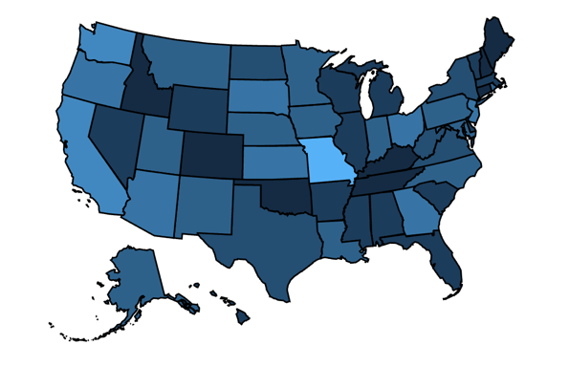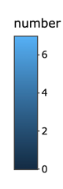
Note: An Interactive version of this map is in the dashboard. See https://treenagoswami.shinyapps.io/project_website/

2.2.1 SDC Mission Statements

We first examined State Data Center (SDC) Mission Statements. Exhibit 3 presents word clouds summarizing the SDC’s Mission Statements from six states: Indiana, Maryland, North Carolina, Florida, California, and Massachusetts. The primary and secondary words reflect the similarity and variation of interests for each SDC, for example:

Indiana – development, business, nonprofits, services, planning, community, organizations
Maryland – development, planning, trends, growth, income, housing, projections
North Carolina – resources, economics, demographic, geographic, analysis, international
Florida – programs, tools, products, maps, redistricting, training, poverty
California – center, public, survey, training, workshops, reports, maps, consultation
Massachusetts – economic, census, research, public policy, networks, local agencies

Exhibit 3: Word clouds derived from State Data Center Missions Statements: Indiana, Maryland, North Carolina, Florida, California, and Massachusetts
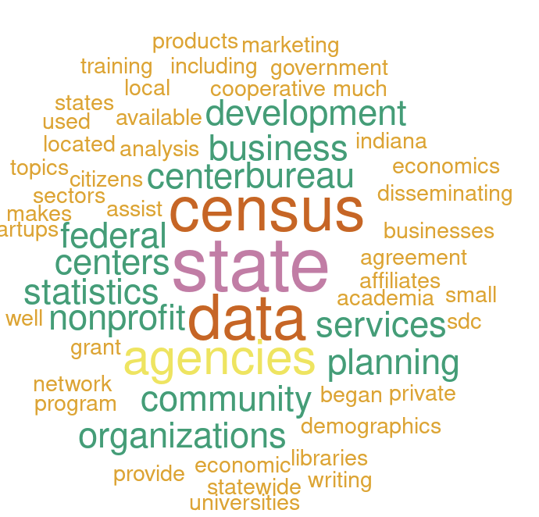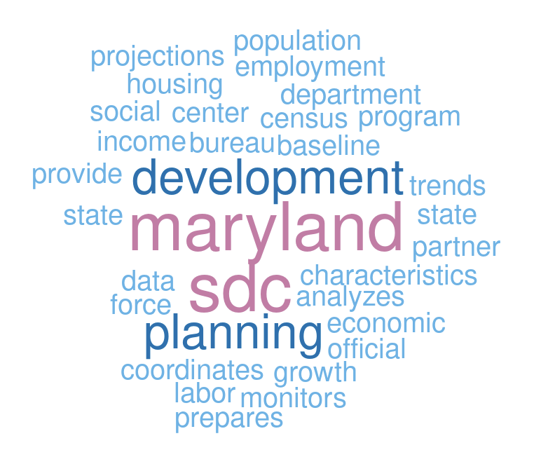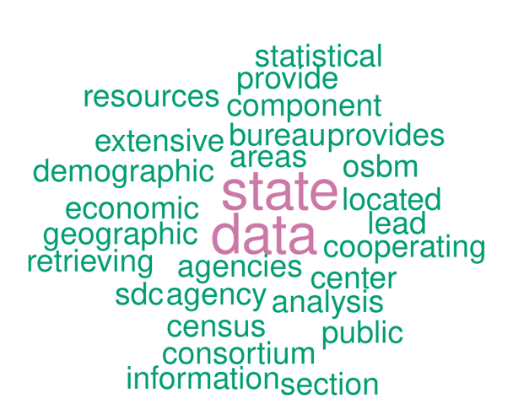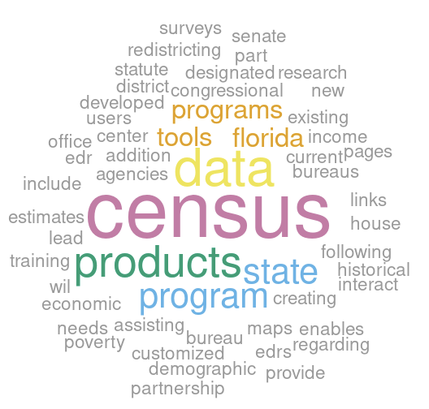
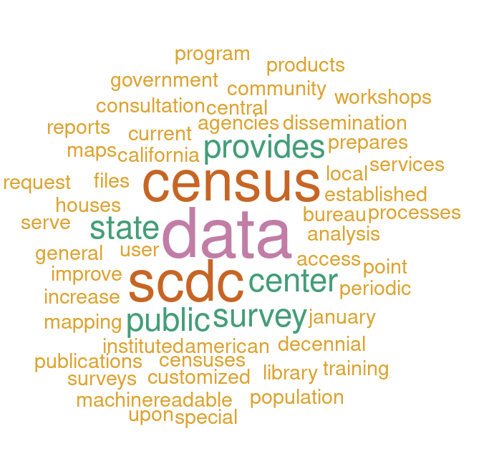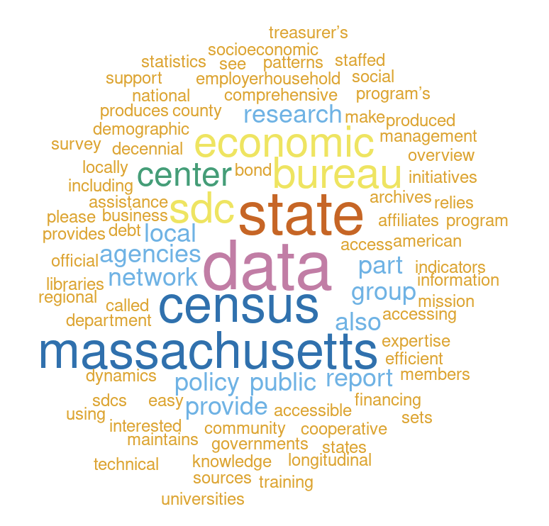

2.2.2 SDC Data Dissemination Websites

We used manual searches as the primary method for collecting information from SDC websites since each SDC website was organized to meet the needs of the state and reflected the amount of resources that SDC received. For details on the web scraping methods used, see Section 3.2.

The SDCs disseminate diverse information across various geographic levels. Based on an in-depth examination of the SDC websites, we organized the findings into six broad categories to enhance accessibility and understanding. These categories include demographics, economy, housing, health, education, and diversity. These classifications are based on our initial scan of the data.

Within each broad category, we created subcategories that reflect the specific topic on the data provided. Exhibit 4 outlines these six main categories along with their respective subcategories. For the specific category of diversity, defined in the context of population estimates and projections, if available, is based on race and ethnicity combined. Additionally, another observation from Exhibit 4 reveals that several subcategories, despite possibly measuring the same aspects, are labeled differently by different states. These differences exemplify the variation in terminology used by states when disseminating comparable data.

Exhibit 4: Broad data categories and subcategories identified in the State Data Centers

Categories | Subcategories
Demographics | Estimates, Projections – Total and by demographics such as age, gender, race
Economy | Economy, Employment, Income, Job, Labor force, Tax, Wage
Housing | Residential Mobility, Projections, Permits, Occupancy, Housing Units, Housing Prices/Rents, Housing Characteristics, Household Size, Household Type, Household Income, Foreclosures,
Health | SNAP, Physicians, Mental Health, Medicaid, Insurance, Incidence Rates, Health Estimates, Health Counts, Health Characteristics, Healthcare, Disability, Births and Deaths
Education | Student Poverty, Student Performance, School Enrollment, School District, School Attendance, Public School, Post-Secondary, Graduation Rates, Educational Attainment, Education Services, Education Estimates, Education Counts, Education Characteristics, Adult Education
Diversity | Race and Ethnicity combined

For the states that present data on diversity, the total number of race and ethnicity categories usually aligned closely with the Office of Management and Budget (OMB) standards. However, some states, such as Alabama, offered limited data, classifying populations broadly into white and non-white. In contrast, some states, such as California, Iowa, and Kansas, provided detailed information, including the enumeration of Native American tribes, resulting in an extensive listing.

The exploration of the SDC data landscape highlights the variety of information provided by SDCs, presenting the details of state-level demographics, economic landscapes, housing dynamics, health indicators, educational trends, and diversity metrics. The variations in data presentation underscore the uniqueness of each state's approach, highlighting the importance of understanding local areas for informed decision-making and policy formulation. Certain state SDCs, such as Delaware, Georgia, Hawaii, Louisiana, Mississippi, New Mexico, redirect data inquiries related to population projections and estimates to the U.S. Census Bureau website.

Exhibit 5 summarizes the number of states and territories reviewed in the six broad data categories. The complete list of states, districts, and territories whose SDCs underwent review is available in Exhibit A1 in Appendix 1.

Exhibit 5: Number of States and Territories Reviewed

Categories | Number of States and Territories
Demographics | 28
Economy | 53
Housing | 52
Health | 53
Education | 52
Diversity | 28

We encountered challenges in locating data for specific categories in certain states. Some of these omissions are attributable to the absence of data in specific categories, whether in the lead SDC or coordinating agencies. For example, health and education data were not found in the SDCs for Louisiana, Idaho, and Delaware. Similarly, housing data was not on the SDC websites for Michigan, Minnesota, and Idaho. The SDCs for the District of Columbia and Louisiana lacked economy-related information. Ongoing review of SDCs for the demographics and diversity categories can be attributed to the lower numbers of SDCs reviewed compared to the other categories.

Display tables and table downloads are the most prevalent methods of data dissemination. The majority of SDCs also disseminate data through visualization, infographics, maps, reports, display tables, and download options across various categories. However, some SDCs, such as Alaska, the District of Columbia, and Iowa, as well as other states, create a variety of maps and infographics for housing, health, and education categories. These types of SDC data releases make the data more useful to the public. Moreover, these products serve as valuable resources for independent researchers seeking specific state characteristics, potentially aiding grant-writing endeavors.

2.2.3 SDC Data Sources and Level of Geographies

The primary source of SDC information is the U.S. Census Bureau, which has commonly referenced statistical products and surveys such as the American Community Survey (ACS) and the Decennial Census. Many SDCs also have data from other federal agencies such as the Bureau of Economic Analysis, the Bureau of Labor Statistics, the U.S. Department of Housing and Urban Development, the U.S. Department of Labor, the Centers for Disease Control and Prevention, and the National Center for Health Statistics. SDCs also have data from nonfederal entities, including state and local agencies that focus on the economy, education, health, housing, and labor.

SDCs also present data by varying geographic levels. The most utilized geographic levels across the six broad data categories (listed above in Exhibit 4) are state and county. This aligns with the fact that the Census Bureau disseminates most of its data at the state and county level, and the Census Bureau is the primary source of information for the SDCs.

Geographic terminology at the local level is more diverse, reflecting administrative structures and traditions. Instances include state or region-specific nomenclatures like 'parishes' in Louisiana, 'towns' in Connecticut, or 'neighborhood clusters' in the District of Columbia. Notably, custom geographies emerge for administrative purposes. One example is groupings of counties related to development of groups of counties, such as 'economic development regions' in Kansas and 'development districts' in Kentucky.

Furthermore, when delving into demographic or diversity data, states with significant American Indian or Alaska Native populations, like Alaska, provide data for 'Native Village Statistical Areas' and 'Native Regional Corporations.' This underscores the importance of recognizing and accommodating region-specific terminologies and structures when interpreting data from SDCs. When it comes to educational data, school districts emerge as a frequently utilized geographic level. Exhibit 6 presents a summary of the different geographies for the 28 states and territories presented in the dashboard (see https://treenagoswami.shinyapps.io/project_website/ ).

Exhibit 6: Summary of Different Geographies for 28 States and Territories
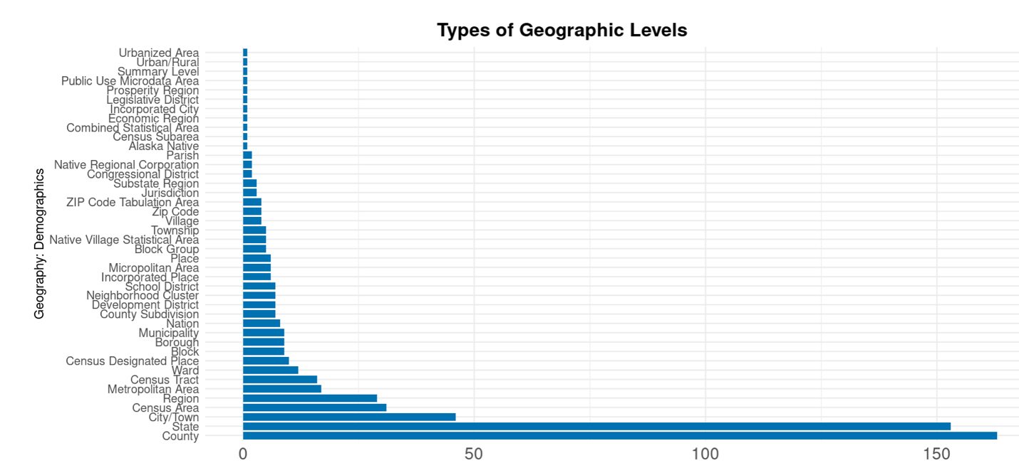
Source: https://treenagoswami.shinyapps.io/project_website/

2.2.4 SDC Early Adopters

We refer to SDCs that exhibit forward-thinking practices within the SDC network as early adopters. These SDCs proactively leverage Census Bureau data while supplementing it with information from state agencies and other federal agencies. These SDCs stand out for their strategic use of multiple data sources, to create statistical products. This proactive approach enables them to release data that addresses the evolving needs of users. Four SDCs stand out as forward-thinking entities, each distinguished by unique approaches in addressing user data needs: Colorado, Kansas, New Mexico, and New York.

The Colorado State Data Center (SDC) publishes population estimates and projections by combining data from various sources, including Census Bureau data such as the American Community Survey and Decennial Census, along with non-Census data from entities like the Colorado Department of Public Health and Environment, Internal Revenue Service, Medicare, and Immigration Statistics.

The Kansas SDC, with its Kansas Regional Data Portal, a dynamic dashboard, offers an overview of regional and county characteristics. Covering diverse categories such as demographics, housing, business, healthcare, quality of life, infrastructure, and natural resources, this user-friendly platform engages users with interactive data presentation. Notably, the portal provides citations for the data, enhancing transparency and credibility.

Situated in the New Mexico Economic Development Department, the New Mexico SDC strategically focuses on economic characteristics. While redirecting population, social, and housing data to Census Bureau products, it excels in providing up-to-date information on the workforce profile. Regular updates, as recent as November 2023, offer timely and relevant economic data.

The New York SDC stands out for its detailed dashboard, encompassing variables from the American Community Survey and Current Population Survey for the state and counties. Beyond conventional data offerings, it provides a Self-Sufficiency Earnings Estimator. This tool, originally developed by the Center for Women’s Welfare, University of Washington, calculates the income required for basic needs, considering family size and geographic location. The inclusion of regional occupational information adds a valuable dimension, aiding users in making informed career decisions.

In summary, these forward-thinking SDCs display a diverse range of strategies, from comprehensive data integration to interactive dashboards and specialized tools. Their initiatives not only address immediate data needs but also pave the way for potential replication and adoption by other SDCs nationwide, contributing to informed users .

2.3 Survey of the Federal-State Cooperative for Population Estimates (FSCPE) Contacts

As background, State FSCPE agencies, designated by their respective governors, work in cooperation with the Census Bureau's Program Branches to produce population estimates, consistent with the last decennial census counts. The Census Bureau begins the process of preparing population estimates by updating population information from the most recent census with information found in the annual administrative records of Federal and state agencies. The Census estimates are sent to the FSCPE agencies for review and comment. Population estimates are used to distribute Federal dollars and to determine eligibility for many social programs which are based on population.

The FSCPE responses to the survey (see Methods, section 3.4) include a diverse range of data sources utilized by different states and territories in the United States. These data sources cover various aspects, including Census data, economic indicators, labor market information, and demographic statistics. For instance, several states rely on data.census.gov for comprehensive Census data, while others utilize specialized tools such as the National Historical Geographic Information System (NHGIS) for historical data. Economic indicators are accessed through sources like the Bureau of Economic Analysis (BEA) and the St. Louis Federal Reserve Economic Data (FRED). States also employ proprietary tools and dashboards developed by the California Department of Finance and the DC Office of Planning to provide detailed demographic, social, and economic insights. These resources play a role in informing decision-making processes, supporting research, and facilitating access to data for planning and development.

Examples from many of the states that responded are included below.
Alaska’s migration tracker allows you to see annual migration between Alaska's boroughs and census areas based on permanent fund dividend filings. https://live.laborstats.alaska.gov/pop/000013/000020/pfdmigr.cfm

Arizona State Demographer's Office produces population estimates and projections. They publish them online using downloadable files. https://www.azcommerce.com/oeo/population/

California Department of Finance Demographic Research Unit releases historical and current population estimates with components of change and rankings, Housing unit counts, demographic, social, economic, migration, and housing data from the decennial censuses, ACS, the Current Population Survey (CPS), and other special and periodic surveys, DRU Data Hub. https://dof.ca.gov/Forecasting/Demographics/

The District of Columbia’s Office of Planning (OP) Demographic Data Hub presents selected demographic, social, housing, and economic data and analysis to help guide decision-making. The information is presented in geographic profiles, policy, interactive and downloadable maps, open data search, reports, studies, and other downloadable resources that users can incorporate into their research and data products. The Hub was built by the DC State Data Center in collaboration with the Environmental Systems Research Institute (Esri) and the DC Office of the Chief Technology Officer (OCTO) and uses many features of the ArcGIS platform and solution templates. https://opdatahub.dc.gov/

The District of Columbia’s Data Dashboard provides a detailed look at key indicators of upward mobility in Washington, DC. They highlight outcomes across racial and ethnic groups as well as across communities.
The dashboard includes data for the DC Upward Mobility Project’s three policy areas— housing, financial well-being, and workforce development/adult education.
The DC State Data Center assisted in building this dashboard and is responsible for management and annual updates. https://upwardmobility.dc.gov/

Hawaii created two data warehouses and a data dashboard:
1. Economic Data warehouse. https://dbedt.hawaii.gov/economic/datawarehouse/
2. DBEDT Tourism Data warehouse. https://dbedt.hawaii.gov/visitor/tourismdata/
3. The DBEDT Dashboards are the main links to various Tableau dashboards. https://dbedt.hawaii.gov/economic/dashboards-main/ we created

Examples of Illinois-created datasets and dashboards include:
Vital Statistics of Illinois, Illinois Department of Public Health. https://dph.illinois.gov/data-statistics/vital-statistics.html
Population projections for Illinois and its counties, Illinois Department of Public Health. https://data.illinois.gov/
Health Disparity Dashboard in Illinois, Chicago, and Illinois Counties, Department of Public
Opioid Data Dashboard, Illinois Department of Public Health. https://idph.illinois.gov/OpioidDataDashboard/

In addition to Census decennial and ACS data, Massachusetts provides data from other federal agencies for their data products.
National Historical GIS (NHGIS) Data Finder: population estimates and projections, public health, transportation, school enrollment, and more.
CDC Wonder dataset Births and deaths data by US County https://wonder.cdc.gov/
National Center for Education Statistics. https://nces.ed.gov/datalab/
Internal Revenue Service, Statistics of Income, SOI Tax Stats - Migration Data. https://www.irs.gov/statistics/soi-tax-stats-migration-data

New York and Virginia are similar. The SDC is a state agency that works closely with a university (Cornell and University of Virginia, respectively).
They produce similar kinds of databases around county and city population estimates, trends, projections, and school district trends.
Virginia also has a dashboard on Virginia Data Dashboard for the 65+ Population: https://demographics.coopercenter.org/data-dashboard-aging-virginia

2.4 Exploration of a Search Platform, Databases, and Nonprofit and Commercial Websites

Exploring search platforms, databases, and websites about data needs provided some common themes across the examples below. These needs are:

To provide required interim reports for federal grant programs;
To track federally funded projects and to demonstrate impact;
To proactively provide data and maps to meet local needs;
To provide data for small areas;
To inform strategies to support local and state populations, e.g., affordable housing strategies and
To conduct impact analysis tailored to policy issues at local and state levels.

2.4.1 Search Platforms

Examples of data needs identified in Policy Map Customer Stories (accessed through the UVA library)

City of Philadelphia – “The City began using PolicyMap for grant applications, but that was just the start. The Philadelphia Division of Housing and Community Development worked with PolicyMap to create a custom report that supplies up-to-date information needed for quarterly reports to HUD to meet the requirements for the Choice Neighborhood grant, which provides funding to revitalize neighborhoods with distressed public or HUD-assisted housing.”

USDA Rural Housing Service – “In 2015, the Rural Housing Service was reaching unprecedented levels of success in helping build small-town health clinics and offering successful loans to families due to a huge budget increase. However, with the flurry of activity within the department, the RHS needed a better way to track the progress of these projects to stay organized and show off their positive impact.”

City of Dallas – “The City of Dallas’s Department of Planning and Urban Design found they frequently reacted to repetitive requests for data and maps, and they needed a proactive solution, both across city government departments and to better serve public requests for information.”

Hawaii Data Collaborative – “Finding meaningful, cohesive data about trends in Hawaii’s communities and a shared understanding of the state of Hawaii residents was challenging due to siloed information and lack of data.”

North Carolina Housing Finance Agency – “To better inform decision-making around affordable housing strategies, NCHFA needed a platform to share housing data with the public easily. When spreadsheets of data proved too inaccessible, and a self-maintained GIS platform proved too cumbersome, NCHFA turned to an interactive, embedded, automatically updated map from PolicyMap.”

Connecticut Housing Finance Authority - CHFA works to alleviate the housing shortage for low- to moderate-income families and persons in Connecticut. To communicate the impact of their investments, staff relied on analysts and complex GIS software. As requests for data pulls, quick maps, and reports grew, CHFA needed a solution for making community housing information more accessible to anyone in the organization. Staff required the ability to explore specific geographies, perform their impact analysis, and geocode information based on legislative districts for meetings with state legislators, community partners, and municipal planners.

3.0 Methods

3.1 Text Analysis of State Constitutions and Amendments

We employed a text analysis of state constitutions to identify state data needs. The first phase involved a manual search, where we collected PDF versions of constitutions and amendments for all 50 states, converting them into text files for future analysis. A detailed examination of seven state constitutions (California, Florida, Kentucky, Louisiana, New York, Virginia, and Washington) followed, with a focus on identifying key terms such as "data," "census," and "information." Additionally, we looked for adjectives that could be addressed by data or related to data, including “minimum,” “maximum,” and “annual,” which could be associated with data. Unfortunately, this manual search did not yield meaningful results, as most state constitutions did not explicitly mention data.

Given the limited success of the manual approach, we opted for topic modeling to gain insights from state constitutions. Topic modeling is a type of statistical model for discovering topics that occur in a collection of text. This would allow us to derive broader topics from the text of states’ constitutions and determine if any topics are related to data or data use. We used two different topic modeling packages, GENSIM and BERT.

When using GENSIM, we experimented with a compilation of the Vermont, Virginia, and Florida state constitutions. GENSIM allows us to specify the number of topics, which we limited to five. Despite efforts to enhance results by excluding common and repetitive words like "this," "that," "has," and "have," GENSIM yielded suboptimal outcomes. Words such as "tax," "amendments," and "bonds" showed up repetitively in multiple topics, and there was noticeable overlap between topic groups. While this approach gave us a general idea about the topic discussed in the state constitution, we wanted more detailed and unique topic groups inside those documents. This curiosity led us to switch the focus to topic modeling using BERT.

BERT stands for Bidirectional Encoder Representations from Transformers—a form of unsupervised learning that encodes text and clusters words from the text into topics. Concentrating on the five states with the most constitutional amendments—California, Texas, Hawaii, Oregon, and Maryland—we used BERT to determine the number of topics in the data. Since BERT is a type of unsupervised learning, we do not specify the number of topics we want, rather, BERT determines how many topics are present in the data. For instance, in the California State Constitution, we identified 101 topics. However, upon examining the top 10 topics, we discovered only broad subjects related to government, featuring words like articles, committees, caucus, and citizenship—that would be commonly expected to be found in a constitution.

BERT Example: Texas Topics

Exhibit 7 presents the eight most frequented topics found within Texas's state constitution and amendments, each accompanied by a set of words and their associated probabilities. These words underline the core themes of each topic. For example, Topic 0, the most frequently occurring topic, encompasses words like 'election,' 'voters,' and 'qualified,' collectively pointing to its relevance to electoral processes. Likewise, Topic 1 revolves around terms associated with positions of authority, including 'governor' and 'lieutenant,' providing insights related to governmental leadership.

Exhibit 7: Eight most frequented topics in the state constitution and amendments of Texas
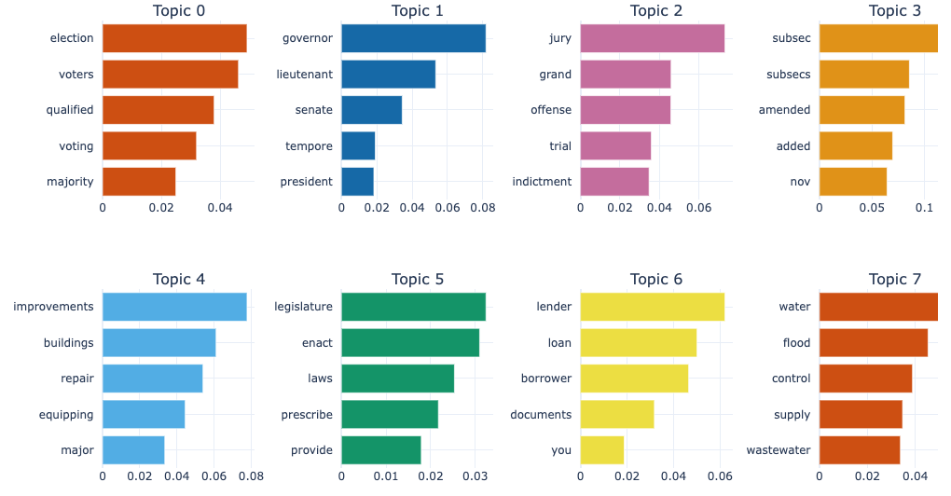

3.2 Web Scrape of SDC Internet Sites

We initiated the data-gathering process through web scraping, a technique involving the extraction of data from websites by loading the HTML and parsing through the content. The first step was to use a Python package for parsing HTML and XML documents, called Beautiful Soup. We used the package to scrape State Data Center (SDC) links from the U.S. Census Bureau site and assess individual SDC sites. To comprehensively evaluate each SDC, we systematically collected links for lead and coordinating agencies for all 50 states and 6 territories, obtaining insights into the diverse agencies collaborating at the state level.

Once we compiled the links, we assessed each SDC's scrapability for data tools collection based on two key criteria: simplicity and organization. A site was deemed scrapable if it exhibited simplicity, featuring a page consolidating all data sources without additional web links, or if it was well-organized, systematically categorizing data and tools with explicit listings of data sources, names, and links.

3.3 Manual Audit of State Data Center Websites

Even though manual search and documentation are time-intensive processes, they provide a more detailed examination of how SDCs utilize and produce data products. Delving into each SDC website, we systematically gathered information on six representative aspects: Demographics, Economy, Housing, Health, Education, and Diversity. Within each aspect, we identified sub-categories and documented specific details such as data tool types, used variables, data sources, and the age of the data.

3.4 Survey of the Federal-State Cooperative for Population Estimates Contacts

To deepen our understanding of the data landscape within each state, we initiated an email survey targeting Federal-State Cooperative for Population Estimates (FSCPE) members. FSCPE is a cooperative effort between the Federal Government and U.S. states and territories established in 1953. FSCPE agencies collaboratively engage with the Census Bureau to generate local population estimates.

Our survey aimed to capture more profound insights into the tools and applications that play a role in data-related initiatives across states. Respondents were asked to identify and rank their state's top six most valuable or important data tools or applications in the survey. Additionally, we sought information on the data sources underpinning these tools and applications. This inquiry aimed to understand the data landscape at the state level, emphasizing the practical utility of specific tools and the foundational data upon which they rely.

We conducted three rounds of outreach to the 56 FSCPE members, resulting in responses from 18 states. Among the respondents, 15 states cited the U.S. Census Bureau as a primary data source. Other frequently mentioned sources included the U.S. Bureau of Labor Statistics, the U.S. Department of Housing and Urban Development, the U.S. Bureau of Economic Analysis, and the U.S. Department of Agriculture. The survey responses from FSCPE members are displayed on our publicly accessible dashboard.

3.5 Exploration of Search Platforms, Databases, and Websites

The team consulted with Jennifer Huck, Associate Director, Research Data Services Liaison to the School of Data Science University of Virginia Library, to address the question about identifying state data needs. The following internet platforms were queried at her recommendation, and databases were searched.

3.5.1 Search Platform
elicit.org – Elicit is an online tool developed by the U.S. nonprofit Ought, a machine learning research lab. The following questions were used to queried.

1. What are the data needs of U.S. state and local governments?
2. What can the Census do to help U.S. State Data Centers?
3. What data do U.S. local governments want?
4. How can the U.S. Census help State Data Centers?
5. What are the United States local government data needs?

3.5.2 Databases
Various iterations of the above questions in Section 3.5.1 were used to search the following two databases that provide insights into many resources. Since we focused on SDCs, we spent limited time exploring data needs through these venues but provide them as another avenue for future research.

Policy Commons (accessed through the University of Virginia (UVA) library) – Policy Commons is a public policy database launched in November 2020. It contains documents from over 10,000 think tanks, nongovernmental organizations, and research centers. The database includes public policy academic and grey literature, for example, reports, policy literature, working papers, newsletters, government documents, speeches, white papers, urban plans, and preserves documents removed from the internet and defunct organizations.

Policy Index File (accessed through the UVA library) – The Policy File Index provides information from over 350 public policy think tanks, nongovernmental organizations, research institutes, university centers, advocacy groups, and other entities. Over 75 public policy topics are covered, from foreign to domestic.

3.5.3 Websites
Various iterations of the questions in Section 3.5.1 were used to search the following nonprofit websites.

Urban Institute – “The Urban Institute is a nonprofit research organization that provides data and evidence to help advance upward mobility and equity.” (Accessed 12/19/2023: https://www.urban.org/about/mission-and-values)

Association of Public Data Users – “The Association of Public Data Users (APDU) is a national network that links users, producers, and disseminators of government statistical data. APDU members share a vital concern about the collection, dissemination, preservation, and interpretation of public data.” (Accessed 12/19/2023: https://www.apdu.org/about-apdu)

Council of State Governments – The Council of State Governments is the nation’s largest nonpartisan organization serving all three branches of state elected and appointed officials. The mission of CSG is to champion excellence in state government.” (Accessed 12/19/2023: https://www.csg.org/about-us/)

National Association of Counties – “Through NACo, counties unite to advocate for county priorities in federal policymaking, promote exemplary county policies and practices, nurture leadership skills and expand knowledge networks, optimize county and taxpayer resources and cost savings, and enrich the public’s understanding of county government.” (Accessed 12/19/2023: https://www.naco.org/page/about-naco)

National Conference of State Legislatures – “NCSL provides objective, fact- and evidence-based (nonpartisan) research, technical assistance, skills training, and other resources to support the policymaking process.” (Accessed 12/19/2023: https://www.ncsl.org/our-work)

Various iterations of the questions in Section 3.5.1 were used to search PolicyMap a commercial website. PolicyMap is an interactive mapping platform that was accessed through the UVA library. It contains over 50,000 indicators accessible through a mapping and analytics platform. PolicyMap provides a service to government agencies to help them with their data needs. They have collected this work on a webpage about customer stories. Relevant customer stories are described in Section 2.4.

4. Conclusions

The lead agencies at the SDCs along with the statewide network of coordinating and affiliate agencies collaborate with the Census Bureau to facilitate easy access and comprehension of Census data and products at the local level. Substantial variations exist among states concerning the accessibility of data on the websites maintained by the leading and coordinating agencies of the SDCs. Four early adopter states were identified for the breadth and depth of their data offerings: Colorado, New Mexico, Kansas, and New York. Other states like Utah and North Carolina proactively develop and update data, tools, and databases. Some states, such as South Dakota, do not always provide the most current data, likely due to limited resources.

The significant variability in the layout of SDCs across states posed a substantial challenge at the project's outset. Our initial strategy aimed to streamline the review process through web scraping tools, which reduced the time investment. As previously mentioned, the criteria for determining the suitability of a website for scraping were simplicity and organization. Simplicity, in this context, refers to a website featuring a page consolidating all data sources without additional web links. An organized website, on the other hand, would systematically categorize data and tools, with explicit listings of data sources, names, and links. However, given the absence of uniform organizational structures across SDCs in different states, we found it necessary to conduct manual searches—a time-intensive process that is still ongoing to comprehensively assess the SDC landscape.

One revelation from the review is around the SDC’s data citation practices. More often than not, SDCs attribute their data to the U.S. Census Bureau without specifying the Census Bureau product or survey. Nearly all SDCs referenced their data sources; however, they did not include Digital Object Identifiers (DOIs) nor data citations.

The introduction of the citation feature within the tables on data.census.gov represents a positive development. This feature not only aids the SDCs but also enhances the ability of other researchers using Census Bureau data to furnish dependable citations.

The examination of individual SDC member webpages, accessible from the member network webpage, revealed that some links are not up to date, e.g., Illinois. This posed challenges during attempts to both web scrape information and manually review the SDCs. For example, the links for the Illinois SDC and Coordinating Agency Census Bureau member webpage did not work.

The examination of State Data Centers (SDCs) has revealed both positive practices and challenges within their operations. By identifying the data sources, tools, and statistical products employed by the SDC network, this initiative aims to inform the development of statistical products, databases, and tools that better address state and local government data needs, fostering improved data access.

5. Recommendations

Conduct regular updates to SDC and Coordinating Agency links on the Census Bureau’s website with SDCs. This could be a monthly or quarterly call to SDCs and Coordinating Agencies to check the links and provide updates to the Census Bureau. This collaborative effort would enhance the accuracy and accessibility of SDC-related information, benefiting researchers and users seeking reliable data. Exhibit A2 in the appendix provides the most current weblinks for few SDCs found in our review.

Provide additional clarity on the Census Bureau citations policy webpage and send regular updates on this policy to SDCs and Coordinating Agencies.

While recognizing the challenges posed by state variations in resources and type of SDC, the Census Bureau could help achieve some level of consistency in the presentation of the data, starting with population trends and projections. Over time, this would help reduce data access disparities across states.

The 2020 Census showed increased racial and ethnic diversity within the U.S. population compared to the previous decade (Menchaca et al. 2023). In light of this, we recommend that the Census Bureau encourage the State Data Centers (SDCs) to enhance the accessibility and widespread reporting of diversity information concerning statewide race and ethnicity distribution. The Bureau could also advocate for adherence to the Office of Management and Budget (OMB) standards related to race and ethnicity categories in data reporting by its SDC partners.

In this study, we were ambitious in undertaking multiple approaches to assess state and local data needs. As a next step, we recommend a deeper dive into fewer states, starting with our list of early adopters (Colorado, New Mexico, Kansas, and New York) and proactive data developers (Utah and North Carolina). A deeper dive could include a more detailed review of the SDC websites, interviews, focus groups with the SDC and Coordinating Agency employees and data users, and other methods to provide a richer overview of SDCs.

References

Keller S, Prewitt K, Thompson J, Jost S, Barrett C, Nusser S, Salvo J, Shipp S. A 21st Century Census Curated Data Enterprise. A Bold New Approach to Create Official Statistics, Technical Report BI-2022-1115. Proceedings of the Biocomplexity Institute, University of Virginia; 2022. DOI: https://doi.org/10.18130/r174-yk24.

Keller S, Shipp S. (2021) Data Acumen in Action. American Mathematical Society. October. https://www.ams.org/journals/notices/202109/noti2353/noti2353.html?adat=October%202021&trk=2353&galt=feature&cat=feature&pdfissue=202109&pdffile=rnoti-p1468.pdf

Menchaca, A., Pratt, B., Jensen, E., & Jones, N. (2023, May 22). Examining the Racial and Ethnic Diversity of Adults and Children. Census.gov Blog. https://www.census.gov/newsroom/blogs/random-samplings/2023/05/racial-ethnic-diversity-adults-children.html

Appendix

Exhibit A1: Inventory of States, District and Territories Reviewed

Categories | Number of States and Territories | State Name Abbreviation | District or Territory Name Abbreviation
Demographics | 28 | AK, AL, AZ, AR, CA, CO, CT, DE, FL, GA, HI, ID, IL, IN, IA, KS, KY, LA, ME, MD, MA, MI, MN, MS, MO | DC, GU, PR
Economy | 53 | AK, AL, AZ, AR, CA, CO, CT, DE, FL, GA, HI, ID, IL, IN, IA, KS, KY, LA, ME, MD, MA, MI, MN, MS, MO, MT, NE, NV, NH, NJ, NM, NY, NC, ND, OH, OK, OR, PA, RI, SC, SD, TN, TX, UT, VT, VA, WA, WV, WI, WY | DC, GU, PR
Housing | 53 | AK, AL, AZ, AR, CA, CO, CT, DE, FL, GA, HI, ID, IL, IN, IA, KS, KY, LA, ME, MD, MA, MI, MN, MS, MO, MT, NE, NV, NH, NJ, NM, NY, NC, ND, OH, OK, OR, PA, RI, SC, SD, TN, TX, UT, VT, VA, WA, WV, WI, WY | DC, GU, PR
Health | 53 | AK, AL, AZ, AR, CA, CO, CT, DE, FL, GA, HI, ID, IL, IN, IA, KS, KY, LA, ME, MD, MA, MI, MN, MS, MO, MT, NE, NV, NH, NJ, NM, NY, NC, ND, OH, OK, OR, PA, RI, SC, SD, TN, TX, UT, VT, VA, WA, WV, WI, WY | DC, GU, PR
Education | 52 | AK, AL, AZ, AR, CA, CO, CT, DE, FL, GA, HI, ID, IL, IN, IA, KS, KY, LA, ME, MD, MA, MI, MN, MS, MO, MT, NE, NV, NH, NJ, NM, NY, NC, ND, OH, OK, OR, PA, RI, SC, SD, TN, TX, UT, VT, VA, WA, WV, WI, WY | DC, GU, PR
Diversity | 28 | AK, AL, AZ, AR, CA, CO, CT, DE, FL, GA, HI, ID, IL, IN, IA, KS, KY, LA, ME, MD, MA, MI, MN, MS, MO | DC, GU, PR
States: Arkansas (AK), Alabama (AL), Arizona (AZ), Arkansas (AK), California (CA), Colorado (CO), Connecticut (CT), Delaware (DE), Florida (FL), Georgia (GA), Hawaii (HI), Idaho (ID), Illinois (IL), Indiana, (IN) Iowa (IA), Kansas (KS), Kentucky (KY), Louisiana (LA), Maine (ME), Maryland (MD), Massachusetts (MA), Michigan (MI), Minnesota (MN), Mississippi (MS), Missouri (MO), Montana (MT), Nebraska (NE), Nevada (NV), New Hampshire (NH), New Jersey (NJ), New Mexico (NM), New York (NY), North Carolina (NC), North Dakota (ND), Ohio (OH), Oklahoma (OK), Oregon (OR), Pennsylvania (PA), Rhode Island (RI), South Carolina (SC), South Dakota (SD), Tennessee (TN), Texas (TX), Utah (UT), Vermont (VT), Virginia (VA), Washington (WA), West Virginia (WV), Wisconsin (WI), Wyoming (WY)
Territories: District of Columbia (DC), Guam (GU), Puerto Rico (PR)

Exhibit A2: List of lead and coordinating agencies of the SDC for the 50 states, District of Columbia and territories, and their appropriate weblinks
State | Organization responsible | Link provided in the Census member network webpage | Appropriate weblink found during review
Alabama | Center for Business and Economic Research | cber.cba.ua.edu
 | Alabama Department of Economic and Community Affairs | adeca.alabama.gov
Alaska | Alaska Department of Labor and Workforce Development | https://live.laborstats.alaska.gov/
 | Alaska Department of Community and Economic Development | https://www.commerce.alaska.gov/web/dcra/
 | Alaska State Library | https://library.alaska.gov
 | University of Alaska-Anchorage | https://consortiumlibrary.org
Arizona | Arizona Office of Economic Opportunity | https://www.azcommerce.com/oeo/population/arizona-state-data-center-sdc/
 | Arizona State University L. William Seidman Research Institute
 | Northern Arizona University | bber.cba.nau.edu | https://nau.edu/franke-college-business/
 | State of Arizona Research Library
 | Economic and Business Research Program | ebr.eller.arizona.edu
Arkansas | University of Arkansas - Little Rock | arstatedatacenter.youraedi.com/
 | Arkansas State Library
California | State Census Data Center-Department of Finance | www.dof.ca.gov
 | Sacramento Area COG | www.sacog.org
 | Southern California Association of Governments | www.scag.ca.gov
 | San Diego Association of Governments | www.sandag.org
 | University of California - Berkeley UC Data Archive and Technical Assistance | ucdata.berkeley.edu
 | Metropolitan Transportation Commission
Colorado | Division of Local Government Colorado Department of Local Affairs | https://demography.dola.colorado.gov
Connecticut | Connecticut Data Collaborative | ctdata.org
Delaware | Delaware Office of Management and Budget | stateplanning.delaware.gov/about/gis-data.shtml
 | College of Urban Affairs and Public Policy University of Delaware | www.cadsr.udel.edu/default.cfm
District of Colombia | Data Analysis and Visualization Unit | planning.dc.gov/node/616182
 | Metropolitan Washington Council of Governments
 | DC Department of Health
 | DC Public Library
Florida | Florida Legislative Office of Economic and Demographic Research | EDR.state.fl.us
 | State Library of Florida
Georgia | Georgia State Data Center | opb.georgia.gov/census-data
 | Government Documents Department
 | Reference Library and Information Department
 | Carl Vinson Institute of Government
 | Georgia Department of Community Affairs
Hawaii | Hawaii State Data Center | www.hawaii.gov/
 | Hawaii State Library
Idaho | Idaho Department of Labor | https://lmi.idaho.gov/data-tools/
Illinois | Community and Economic Development | https://extension.illinois.edu/ | https://extension.illinois.edu/ilcensus
 | Chicago Metropolitan Agency for Planning | https://www.cmap.illinois.gov/
Indiana | Indiana State Library | www.in.gov/library/isdc.htm
 | Indiana Business Research Center (IBRC) | www.ibrc.indiana.edu/
 | Indiana Department of Workforce Development
 | Indiana Geographic Information Council
Iowa | State Library of Iowa | www.iowadatacenter.org
 | Regional Economic Capacity Analysis Program (RECAP) | www.icip.iastate.edu/about/recap
 | Center for Social and Behavioral Research
 | Department of Sociology
Kansas | Institute for Policy and Social Research | https://ipsr.ku.edu/sdc/
 | State Library of Kansas | kslib.info/423/State-Data-Center
 | The Docking Institute of Public Affairs | https://www.fhsu.edu/docking/
 | Center for Economic Development and Business Research | www.kansaseconomy.org/
 | Kansas Department of Commerce
 | League of Kansas Municipalities
Kentucky | University of Louisville | www.ksdc.louisville.edu/
Louisiana | Louisiana State Census Data Center | www.louisiana.gov/demographics-and-geography/
 | State Library of Louisiana | www.state.lib.la.us/
 | Center for Business and Economic Research | www.ulm.edu/cbss/cber/
 | Louisiana State University A and M
Maine | Office of the State Economist | www.maine.gov/dafs/economist/census-information
Maryland | Maryland Department of Planning | www.mdp.state.md.us/msdc/
 | McKeldin Library | www.lib.umd.edu/mckeldin
 | Enoch Pratt Free Library | www.prattlibrary.org/
 | Maryland SBD Center
Massachusetts | University of Massachusetts Donahue Institute | https://donahue.umass.edu/business-groups/economic-public-policy-research/massachusetts-state-data-center
 | Metropolitan Area Planning Council
Michigan | Michigan Department of Technology, Management, and Budget | milmi.org/population
 | Data Driven Detroit
Minnesota | Minnesota State Demographic Center | www.mn.gov/admin/demography/
 | Minnesota Population Center | https://pop.umn.edu/
 | Metropolitan Council | https://metrocouncil.org/data
 | Minnesota Compass - Wilder Research Center | www.mncompass.org/
Mississippi | Center for Population Studies & State Data Center | https://sdc.olemiss.edu/
 | IHL/MARIS
Missouri | Missouri State Data Center | mcdc.missouri.edu/
 | Center for Health Policy | https://medicine.missouri.edu/centers-institutes-labs/health-policy
 | City of St. Louis Planning and Urban Design Agency | www.stlouis-mo.gov/government/departments/planning/
 | East-West Gateway Council of Governments | www.ewgateway.org/
 | Missouri Economic Research and Information Center
 | Missouri Office of Administration
 | Missouri Spatial Data Information Service
 | Mid-America Regional Council
Montana | Census and Economic Information Center | ceic.mt.gov/
 | Montana State Library
 | Bureau of Business and Economic Research | www.bber.umt.edu/
 | Research Analysis Bureau | www.ourfactsyourfuture.org/ | https://lmi.mt.gov/dashboards/datadashboards
Nebraska | Center for Public Affairs Research | www.unomaha.edu/cpar
 | Nebraska Library Commission | nlc.nebraska.gov/
 | Nebraska Department of Labor | dol.nebraska.gov/
 | Nebraska Department of Natural Resources | www.dnr.nebraska.gov
Nevada | Nevada State Data Center | nsla.nv.gov | https://nsla.nv.gov/state-data-center
 | Department of Taxation
New Hampshire | New Hampshire Office of Planning and Development | http://www.nh.gov/osi/data-center
New Jersey | New Jersey State Data Center | lwd.dol.state.nj.us/labor/lpa/content/njsdc_index.html
 | New Jersey State Library
 | Data and Statistical Services
 | Rutgers Regional Report
 | Rutgers University- Alexander Library
New Mexico | New Mexico Economic Development Department | /About the New Mexico State Data Center Program - New Mexico EDD | https://edd.newmexico.gov/
 | Bureau of Business and Economic Research | bber.unm.edu
 | Department of Economics
 | New Mexico State Library
New York | New York State Data Center | labor.ny.gov/nys-data-center
 | Cornell Program on Applied Demographics | https://pad.human.cornell.edu
 | New York State Library | www.nysl.nysed.gov
North Carolina | NC Office of State Budget and Management | www.osbm.state.nc.us/ncosbm/facts_and_figures/state_data_center.shtm
 | State Library of North Carolina
 | Odum Institute for Research in Social Science | www.irss.unc.edu | https://odum.unc.edu/
 | Center for Geographic Information and Analysis | www.cgia.state.nc.us
North Dakota | North Dakota Department of Commerce | www.commerce.nd.gov/census | https://www.commerce.nd.gov/
 | Department of Geography
 | North Dakota State Library
Ohio | Office of Research | development.ohio.gov | https://www.bgsu.edu/arts-and-sciences/center-for-family-demographic-research/ohio-population-news/ohio-state-data-center.html
 | State Library of Ohio
 | Northern Ohio Data and Information Services (NODIS) | urban.csuohio.edu/nodis | https://levin.urban.csuohio.edu/nodis/the_data_connection.html
 | Buckeye Hills-Hocking Valley Regional Development District | www.buckeyehills.org
 | Miami Valley Regional Planning Commission
Oklahoma | Oklahoma Census Data Center | https://www.okcommerce.gov/doing-business/data-reports/census-2020-demographics/ | https://www.okcommerce.gov/doing-business/#data-reports
Oregon | Population Research Center | www.pdx.edu/prc
 | Oregon Employment Department
 | Document Center | library.uoregon.edu/govdocs
 | Office of Economic Analysis | www.oregon.gov/DAS/OEA
 | Oregon State Library | www.oregon.gov/OSL
Pennsylvania | Pennsylvania State Data Center Institute of State and Regional Affairs | https://pasdc.hbg.psu.edu
 | Pennsylvania State Library
 | PA SDC Institute of State and Regional Affair
 | Pennsylvania State Data Center
Rhode Island | Rhode Island Department of Administration | www.planning.ri.gov/geodeminfo
 | RI Department of Labor and Training
 | Rhode Island Economic Development Corporation | commerceri.com
 | Brown University
South Carolina | SC Revenue and Fiscal Affairs Office | www.rfa.sc.gov | https://rfa.sc.gov/data-research/population-demographics/census-state-data-center
 | South Carolina State Library
South Dakota | South Dakota State Data Center | https://www.sdstate.edu/sociology-rural-studies/census-data-center
 | South Dakota State Library | library.sd.gov/
 | Labor Market Information Center | dlr.sd.gov/lmic/
 | South Dakota Department of Health | https://doh.sd.gov
 | Rural Life Census Data Center
Tennessee | Boyd Center for Business and Economic Research | tndata.utk.edu/
Texas | Texas Demographic Center | demographics.texas.gov
 | Texas Natural Resources Information System (TNRIS) | https://tnris.org/
 | Texas State Library | https://www.tsl.texas.gov/
Utah | Kem C. Gardner Policy Institute | gardner.utah.edu/demographics/
 | Department of Workforce Services | jobs.utah.gov
 | Governor's Office of Management and Budget | gomb.utah.gov
 | Office of Vital Records and Statistics | www.health.utah.gov/vitalrecords
Vermont | Center for Rural Studies | www.uvm.edu/crs/
 | Vermont Department of Libraries | libraries.vermont.gov/
Virginia | Virginia Employment Commission | www.vec.virginia.gov/
 | Libraries of Virginia
 | Weldon Cooper Center for Public Service | https://www.coopercenter.org
Washington | Office of Financial Management | www.ofm.wa.gov/
 | Puget Sound Regional Council | www.psrc.org/
 | University of Washington | www.washington.edu/
 | Washington State Library | https://www.sos.wa.gov/
 | Washington State University | wsu.edu/
 | Employment Security | esd.wa.gov
West Virginia | West Virginia Department of Economic Development | www.westvirgina.gov
 | Bureau of Business and Economic Research | https://business.wvu.edu/centers/bureau-of-business-and-economic-research
 | Reference Library | www.librarycommission.wv.gov/
Wisconsin | Demographic Services Center | doa.wi.gov/demographics
 | Applied Population Laboratory | www.apl.wisc.edu/
Wyoming | Department of Administration and Information | eadiv.state.wy.us/
 | Wyoming Survey & Analysis Center (WYSAC) | wysac.uwyo.edu/wysac/
U.S. Virgin Islands | University of the Virgin Islands | https://uvi.edu/research/eastern-caribbean-center
 | Virgin Islands Department of Economic Development
Commonwealth of the Northern Mariana Islands | Department of Commerce | https://ver1.cnmicommerce.com/divisions/central-statistics/
Puerto Rico | Puerto Rico Institute of Statistics | https://estadisticas.pr/
Guam | Bureau of Statistics and Plans | https://bsp.guam.gov/census-of-guam/
American Samoa | Department of Commerce | https://www.doc.as.gov/stats
* The lead agency for each state is highlighted in grey.

